# Database Design

Data normalization: no redundant information

Failure of data integrity: when a customer has two dates of birth.

Primary key: must be a unique combination within the table.

Contents

Database Design 1

1NF 1

2NF 1

3NF 1

3NF 1

4NF 1

5NF 1

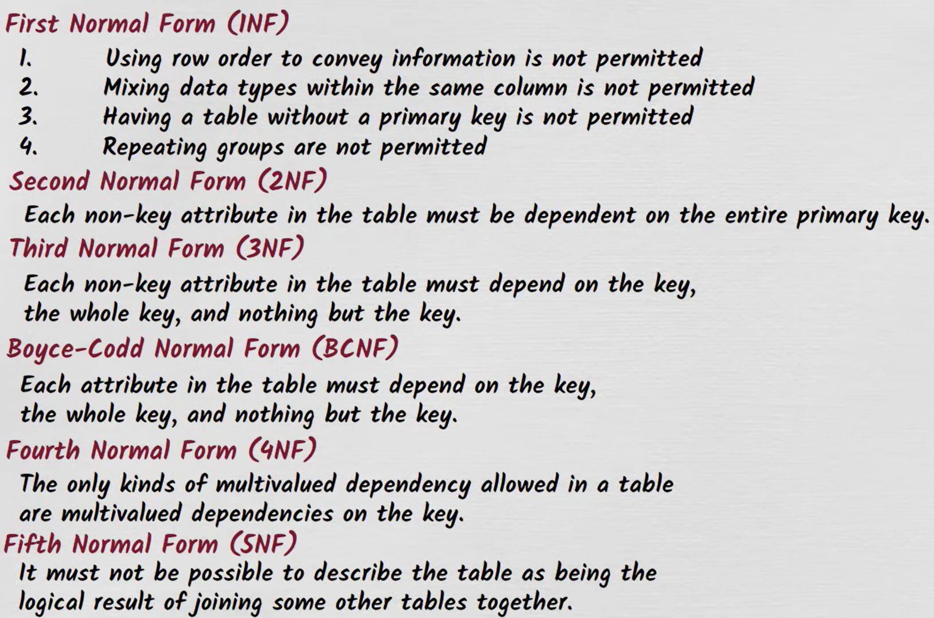

## 1NF

* Using row order to convey information violates 1NF.
* Mixing data types within the same column violates 1NF.
* A table without a primary key violates 1NF.
* Storing a repeating group of data items on a single row violates 1NF.

Good design:

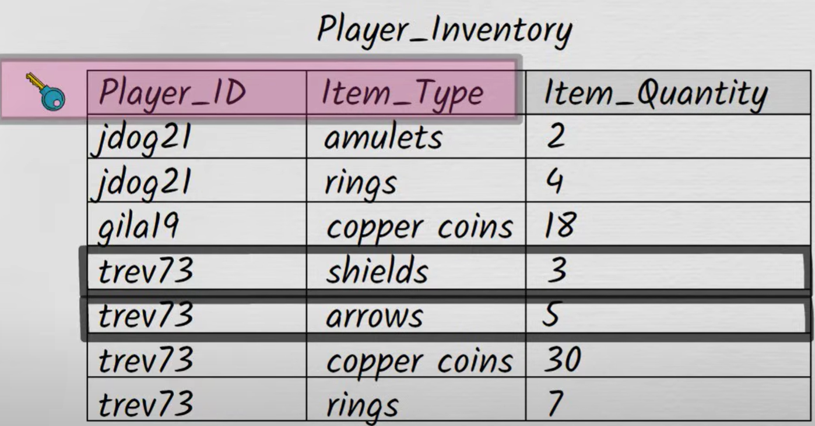

Bad design:

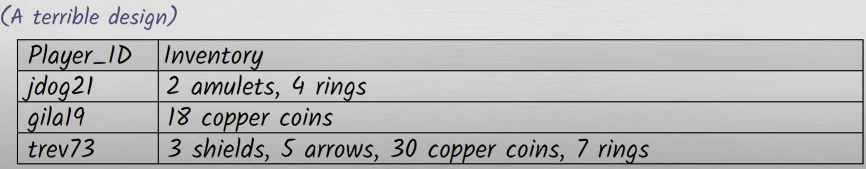

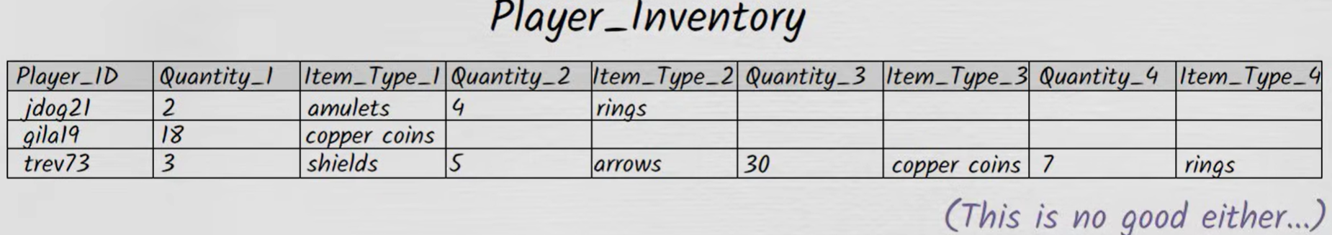

## 2NF

* Each non-key attribute must depend on the entire primary key.

Good design:

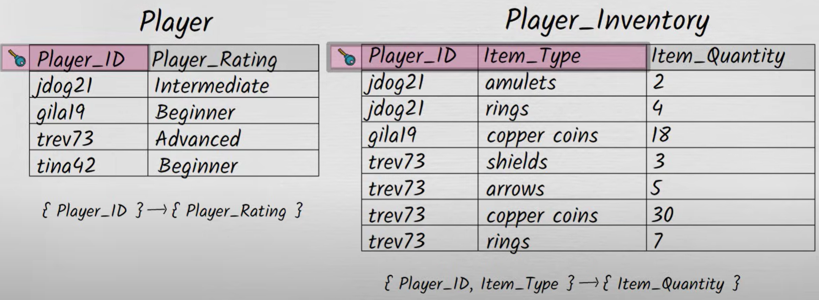

Bad design:

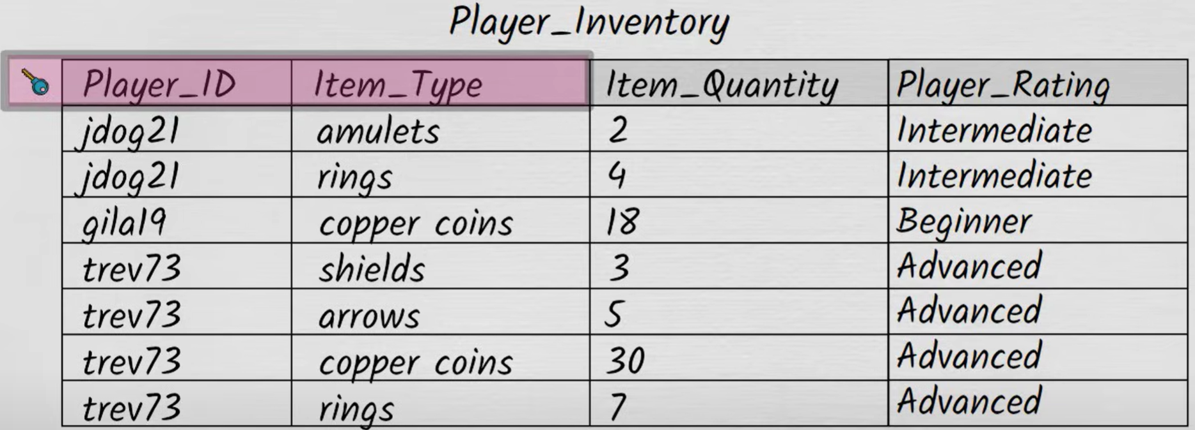

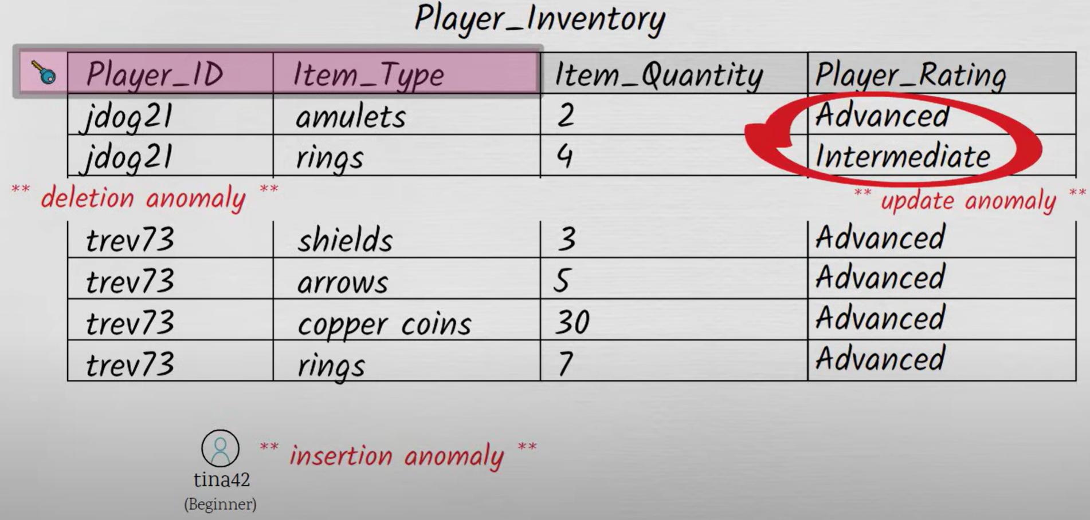

## 3NF

* Every (non-key) attribute in a table should depend on the key, the whole key, and nothing but the key (Boyce-Codd Normal Form).

Good design:



Bad design:

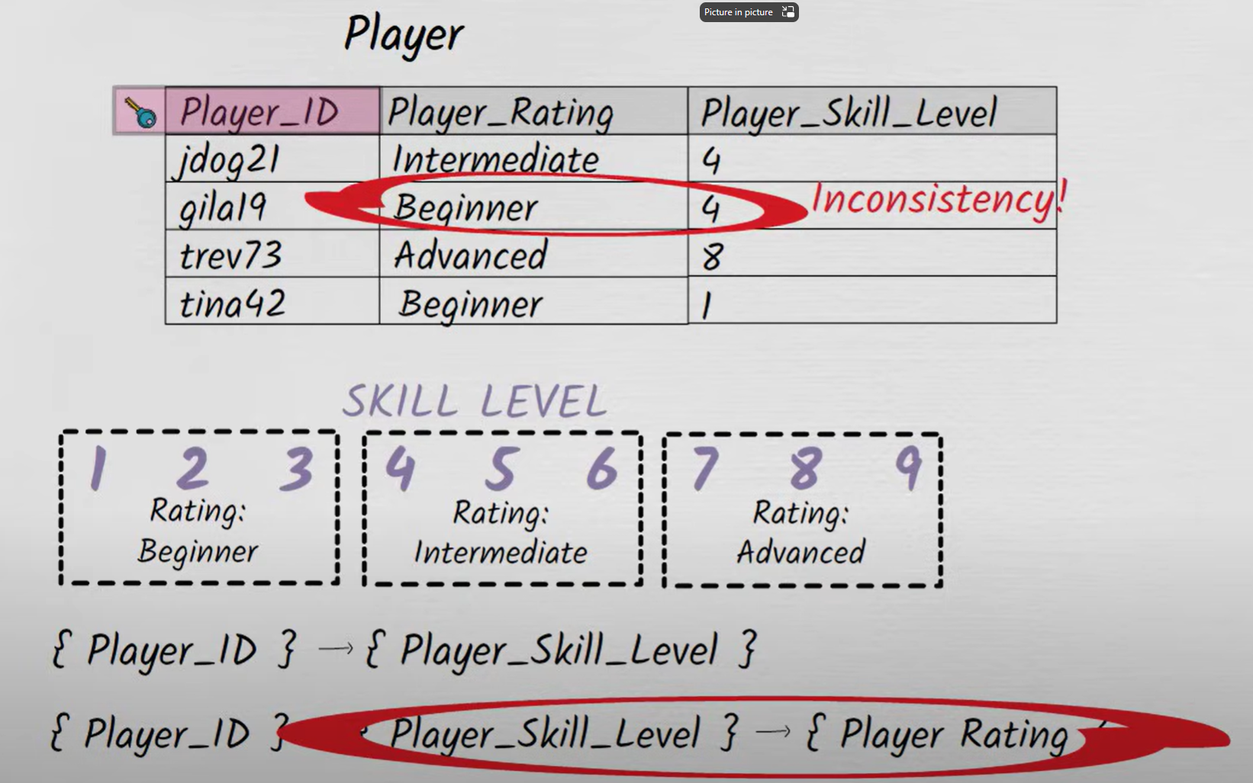

## 4NF

* Multivalued dependencies in a table must be multivalued dependencies on the key.

Good design:

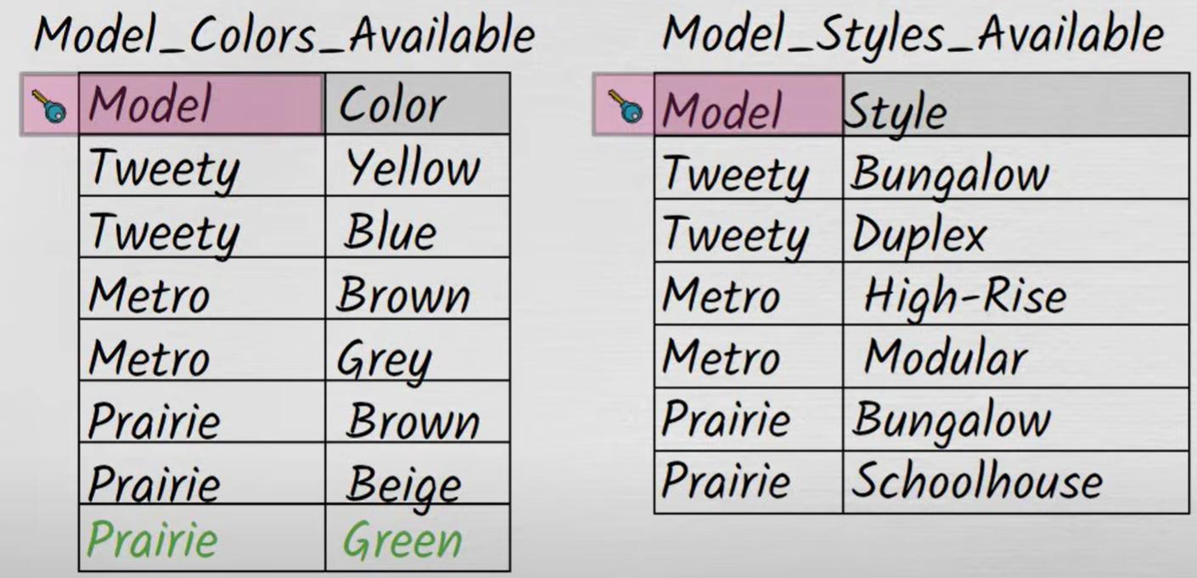

Bad design:

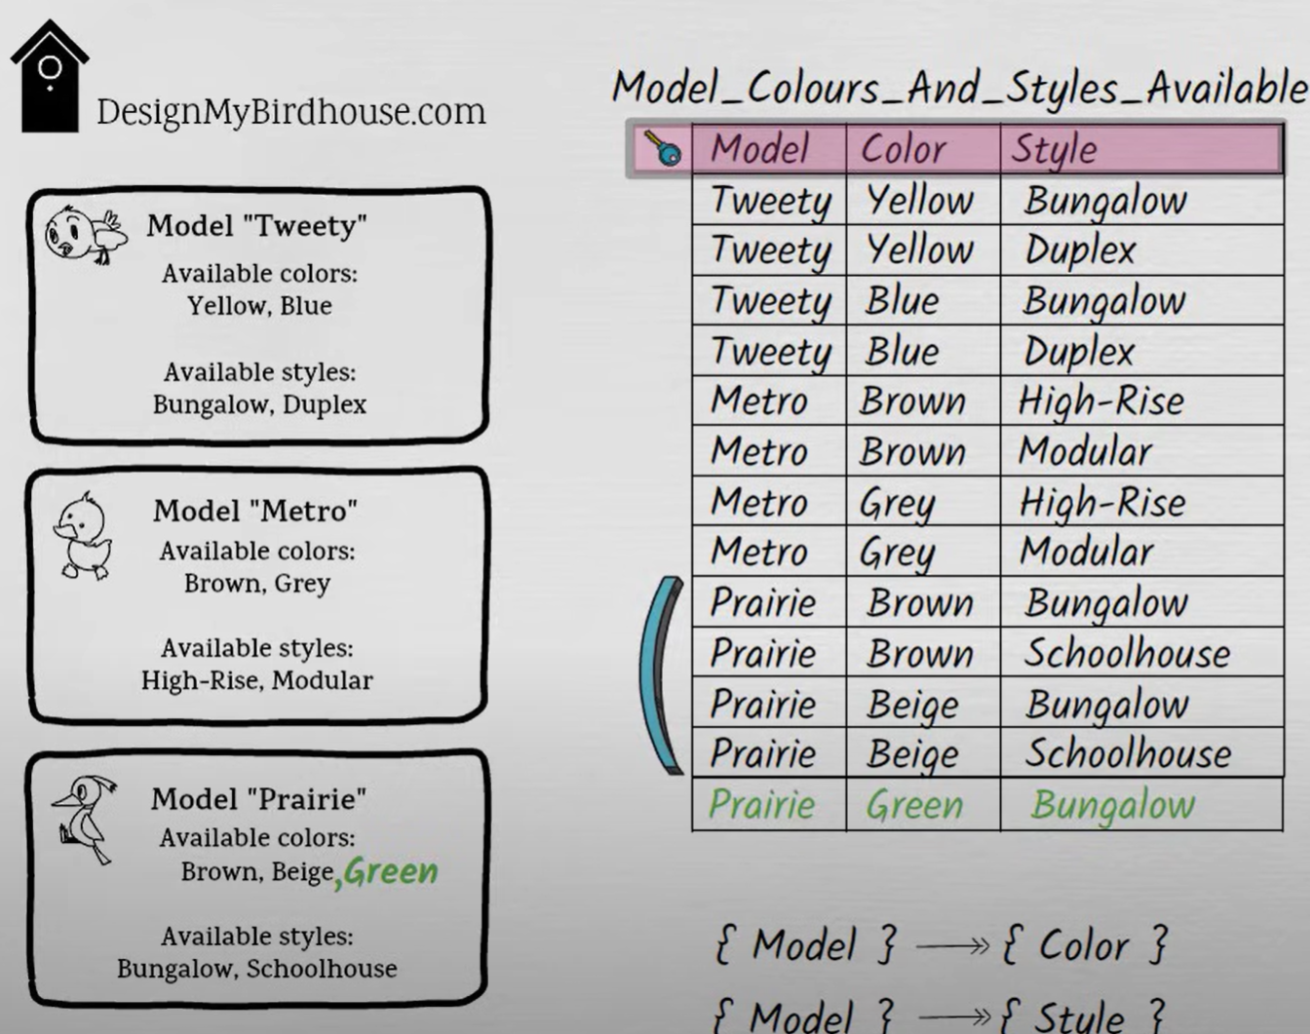

In the Fourth Normal Form (4NF) section, at [23:27](https://www.youtube.com/watch?v=GFQaEYEc8_8&t=1407s) the primary key for the Model_Colors_Available table should appear as {Model, Color}; the primary key for the Model_Styles_Available table should appear as {Model, Style}. Also, the video's informal definition of 4NF - which states that multivalued dependencies on a non-key aren't allowed - is a little too simplistic. I should have said that what's forbidden are "non-trivial" multivalued dependencies on a non-key. "Trivial" multivalued dependencies on a non-key - like Model ->> Color in the case of the Model_Colors_Available table - are fine! A multivalued dependency is considered trivial if the attribute(s) on the left side of the arrow (in this case, Model) and the attribute(s) on the right side of the arrow (in this case, Color) together make up all the attributes in the table.

## 5NF

n the Fifth Normal Form (5NF) section, the summary at [26:16](https://www.youtube.com/watch?v=GFQaEYEc8_8&t=1576s) says that a table (call it T) violates 5NF if it can be "logically thought of as being the result of joining some other tables together." I should have clarified that it if those "other tables" all have the same key as the table T, then it doesn't count as a violation! For example, the fact that a table with columns ( Product_ID (PK), Product_Name ) joins to a table with columns ( Product_ID (PK), Product_Color ) to yield a table PRODUCT which has columns ( Product_ID (PK), Product_Name, Product_Color ) doesn't mean that PRODUCT violates 5NF. More generally, I now think there was a little too much looseness in my presentation of 5NF; I'll do a standalone 5NF video at some point that describes 5NF in a less question-begging way. The same goes for 4NF!

* The table (which must be in 4NF) cannot be describable.

as the logical result of joining some other tables together.

Good design:

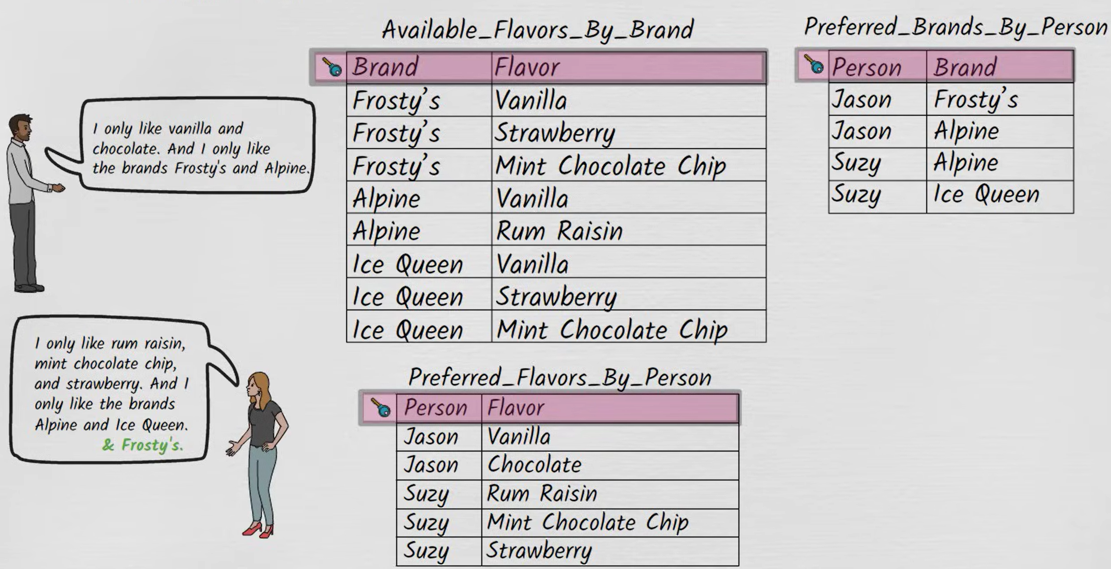

Bad design:

